DNS Lookup Step

Objective

The Domain Name System (DNS) is a distributed directory that resolves human-readable hostnames, such as www.dyn.com, into machine-readable IP addresses like 50.16.85.103.

With the DNS Check API, you can monitor the status of both individual DNS records and groups of related DNS records.

UI

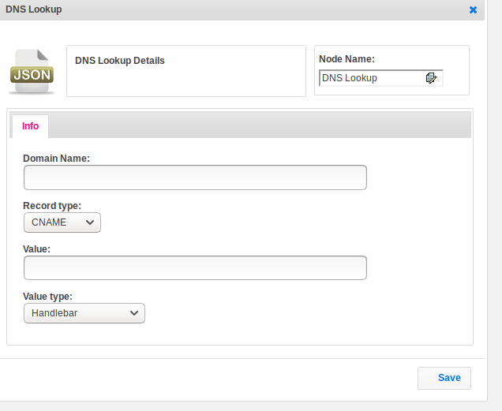

## Attributes

|  |  |
| --- | --- |
| **Attributes** | **Description** |
| **1. Domain Name** | Name of the domain |
| **2. Record Type** | Uses the DNS protocol to resolve all records (also known as ANY or * query). The ret argument passed to the callback function will be an array containing various types of records. Each object has a property type that indicates the type of the current record. And depending on the type, additional properties will be present on the object:  ex:CNAME,A,AAAA,HINFO,ISDN,MX etc |
| **3. Value** | Value of the record. |
| **4. Value Type** | Value_type used to set the value type.  Value types are two types.  1.hb-HandleBars  2.ftl-Freemarker Template Language. |

## Executor Description:

The Domain Name System (DNS) is a distributed directory that resolves human-readable hostnames, such as www.dyn.com, into machine-readable IP addresses like 50.16.85.103.

## Resource:

Please find the below link to get more information.

<https://nodejs.org/api/dns.html>